ORF 401 LAB 1

Robert Shi

1). Totally downloaded the apps

2). Can’t find any. Everyone uses professional services / event planning software that vales peoples’ privacy to some extent.

Used <https://www.briandunning.com/sample-data/> to generate 500 random fake names and addresses.

500 addresses, pseudo-random generated time from a “uniform” 24hr distribution. Assume people from all over the US want to come to Princeton for an awesome event on Valentines day.

3). Ridedirs.com

-almost a palindrome which is kinda symbolic since we are planning to deal with going to and returning from an event.

-Can be interpreted as a ride-directory like a directory for rides and/or ride-direction since people are going to and from an event.

-ridedirs sounds like “riders” that suggest multiple occupants in a vehicle.

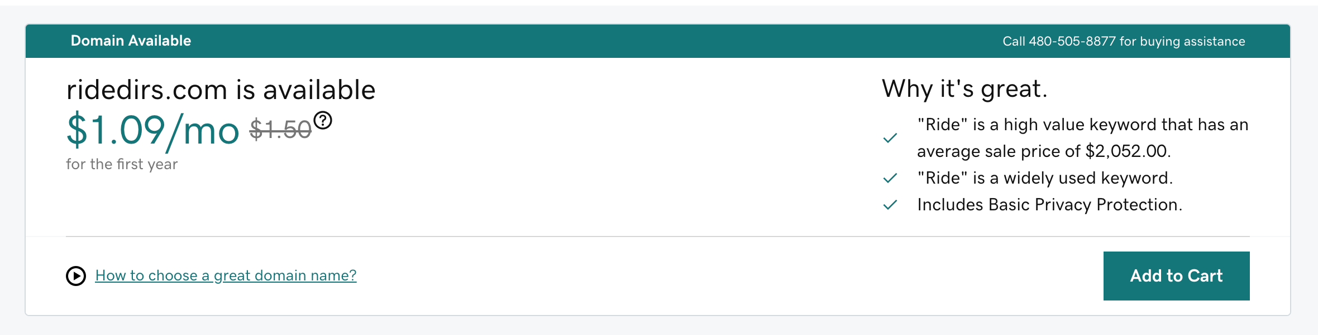

^^^ the .com address is also super cheap (for the first year)

4. Added to the or statement.

Already case insensitive

I made the assumption that everyone is coming to Princeton, so the state search isn’t working too hot. I can quickly add in a field for origin state to help with state searches. Turned required to false for input forms. Then sequentially take subsets of arrays depending on filters for search terms to basically find the intersection of arrays/sets so results satisfy all search conditions.

5.

This product will target event planning/planners. It will allow organizers to search for people and where they are coming from, in order to minimize the number of vehicles necessary for travel to and from the event. We will create a subscription service for our product and users will gain the benefit of promoting their event as environmentally friendly and as having a low carbon-footprint. The costs will come from hosting the site, enhancing user privacy, and potentially services to acquire participant data for ease of use.